Software for Hotel Management
2016
working version 0.1.4
Dirty and muddy

Software Requirements Specification

Version 0.1.4

February, 2016

Software for hotel management

Rumen Kovachev
Sasho Cherkezov
George Stoilov
Maximillian Mitev
Mustafa Burch Adjarala

Table of Contents

Table of Contents i
List of Figures iii
1.0. Introduction 3
1.1. Purpose 3
1.2. Scope of Project 3
1.3. Glossary 2
1.4. References 2
1.5. Overview of Document 2
2.0. Overall Description 4
2.1 System Environment 4
2.2 Functional Requirements Specification 8
2.2.1 Guest use case 8
Use case: Check-in 8
Use case: Check-out 8
2.2.2 Receptionist Use Case 9
Use case: View guests 9
Use case: Room information 9
Use case: Accommodate a guest 10
Use case: Edit guest 11
Use case: Check-out a guest 11
Use case: Report manager 12
Use case: Add report 12
Use case: Mark report with status 13
Use case: Edit report 13
Use case: Calendar management 14
Use case: Add event to the calendar 14
Use case: Edit event to the calendar 15
Use case: Remove event to the calendar 15
Use case: View Invoices 15
Use case: Create Invoice 16
Use case: Edit Invoice 16
Use case: Delete Invoice 17
2.2.3 Manager Use Case 17
Use case: Review the reports 17
Use case: Room types management 18
Use case: Add room types 18
Use case: Remove room types 19
Use case: Edit room types 19
Use case: Types of Services 20
Use case: Add service 20
Use case: Remove service 21
Use case: Edit service 21
Use case: Report manager 22
Use case: Add report 22
Use case: Mark report with status 23
Use case: Edit report 23
Use case: Calendar management 24
Use case: Add event to the calendar 24
Use case: Edit event to the calendar 25
Use case: Remove event to the calendar 25
2.3 User Characteristics 26
2.4 Non-Functional Requirements 26
3.0. Requirements Specification 28
3.1 External Interface Requirements 28
3.2 Functional Requirements 28
3.2.1 Check-in method 28
3.2.2 Check-out method 29
3.2.3 View guests method 29
3.2.4 Room accommodation method 29
3.2.5 Edit guest method 29
3.2.6 Check-out method 30
3.2.7 Report CRUD methods 30
3.2.8 Calendar CRUD methods 31
3.2.9 Invoice CRUD methods 31
3.2.10 Room type CRUD methods 31
3.2.11 Service type CRUD methods 32
3.2.12 Report CRUD methods 32
3.2.13 Calendar CRUD methods 33
3.3 Detailed Non-Functional Requirements 34
3.3.1 Logical Structure of the Data 34

1.0. Introduction

1.1. Purpose
The purpose of this document is to present a detailed description of the Software for hotel management. It will explain the purpose and features of the system, the interfaces of the system, what the system will do, the constraints under which it must operate and how the system will react to external stimuli. This document is intended for both the stakeholders and the developers of the system.

1.2. Scope of Project
This software system will be a System for Hotel management for a local hotel in Kazanluk, Bulgaria. This system will be designed to maximize the hotel’s performance and guest management as well as providing internal link between the different functional parts of the hotel. By doing so, the workflow with be improved as well as minimizing the efforts in managing hotel’s guests, which otherwise would become a time consuming experience.
More specifically, this system is designed to provide the receptionist with powerful set of tools in order to be faster, while performing guests’ accommodations, giving the managers all the information, they need for running the hotel, in one place and to provide exclusive internal link between reception staff, kitchen staff, manager and the rest of the personal, working in the hotel, while keeping a strict and easy-to-use database of the guests and there past, present or future relation towards the hotel.

1.3. Glossary
Term | Definition
Receptionist | The person in the reception, working with guests and filling information in the system
Manager | The person who manages the hotel
Guest | Person that is being accommodated for a period in time in the hotel
Database | Collection of all the information monitored by this system.
CRUD | Abbreviation for Create-Read-Update-Delete. Basic functionality in MVC
Field | A cell within a form.
Software Requirements Specification | A document that completely describes all of the functions of a proposed system and the constraints under which it must operate. For example, this document.
User | Receptionist or Manager

1.4. References
IEEE. IEEE Std 830-1998 IEEE Recommended Practice for Software Requirements Specifications. IEEE Computer Society, 1998.

1.5. Overview of Document
The next chapter, the Overall Description section, of this document gives an overview of the functionality of the product. It describes the informal requirements and is used to establish a context for the technical requirements specification in the next chapter.
The third chapter, Requirements Specification section, of this document is written primarily for the developers and describes in technical terms the details of the functionality of the product.
Both sections of the document describe the same software product in its entirety, but are intended for different audiences and thus use different language.

2.0. Overall Description

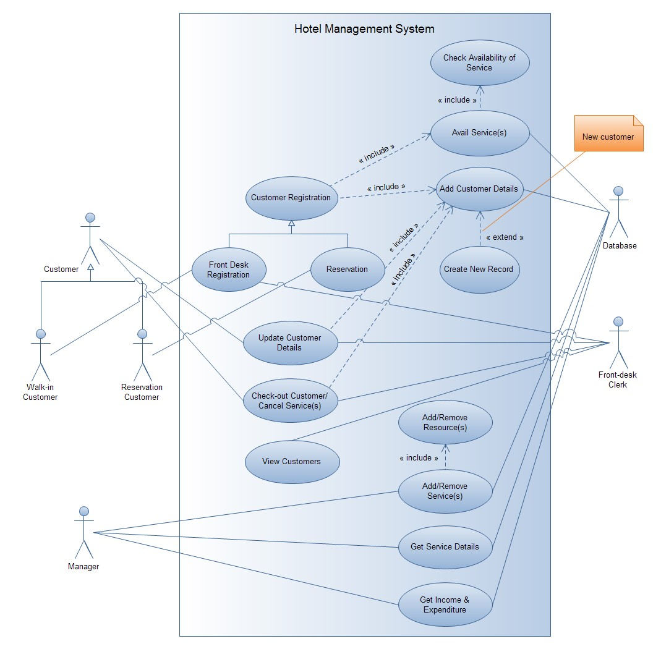

2.1 System Environment

Figure 1 - System Environment
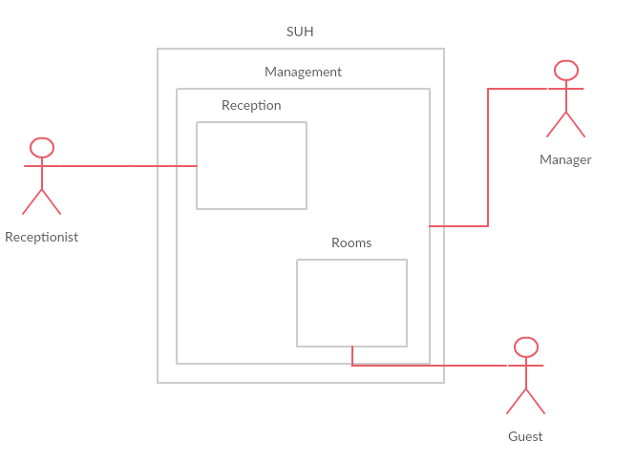
The Hotel Management System has three active roles, two part administrating system and one floating role. The receptionist is in charge of guests’ accommodation and is part of the first administrating system, which is entirely focus on guest management. The manager is another word for the hotel owner and is part of the second administrating system. His role is to configure the system, fill the room types as well as providing feedback and working with the daily, monthly and yearly reports.

Figure 2 – Gant chart
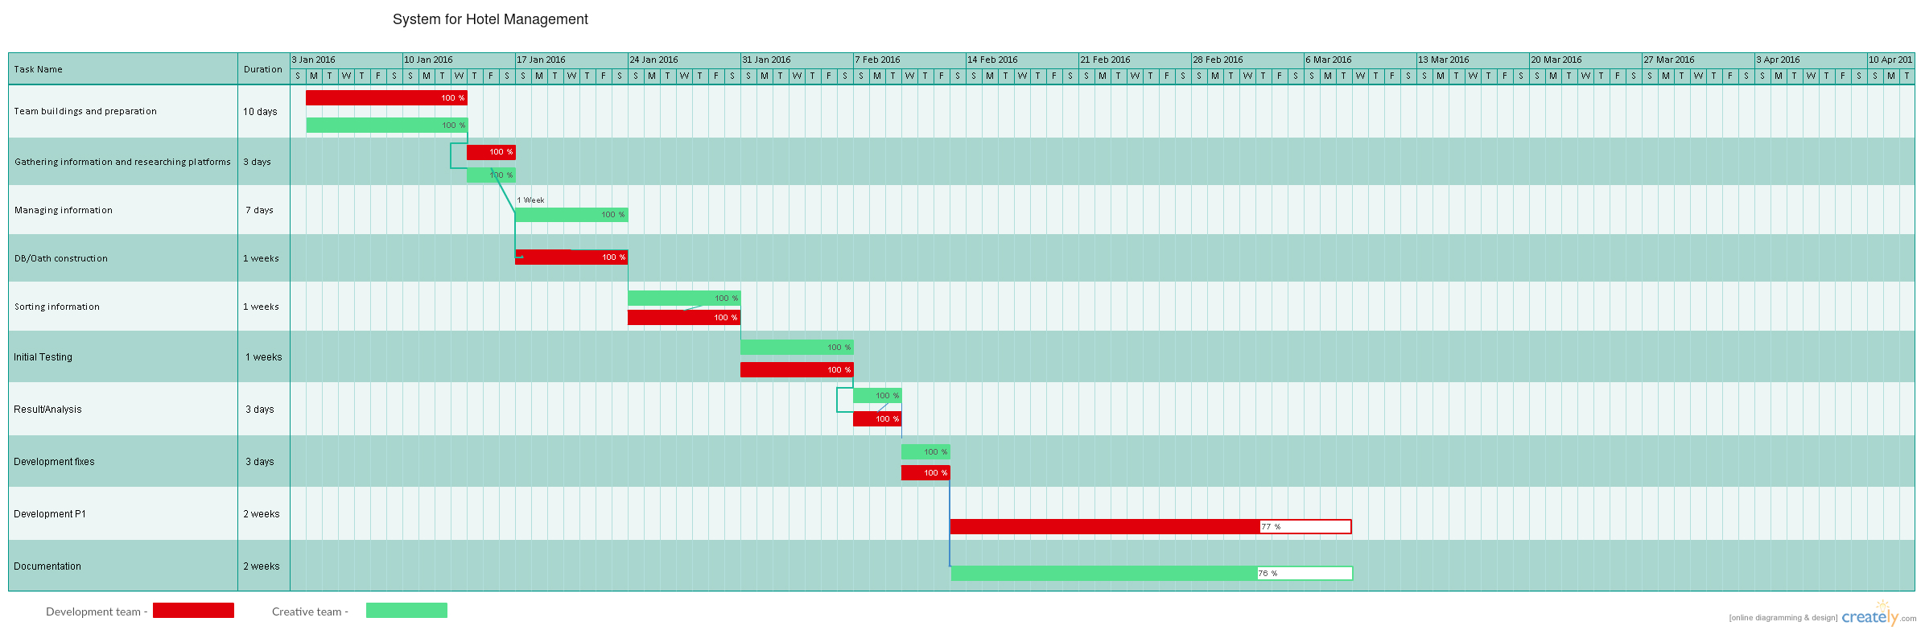

Figure 3 – Time table

Name | Duration | Team | Must be done
Team buildings and preparation | 10 days | Developing team  Creative team
Gathering information and researching platforms | 3 days | Developing team  Creative team | 1
Managing information | 7 days | Creative team | 2
DB/Oath construction | 7 days | Developing team | 2
Sorting information | 7 days | Developing team  Creative team | 3,4
Initial testing/Coding | 7 days | Developing team  Creative team | 5
Result/Analysis | 3 days | Developing team  Creative team | 6
Developing fixes | 3 days | Developing team  Creative team | 7
Development P1 | 14 days | Developing team | 8
Documentation | 14 days | Creative team | 8

Figure 4 – Database
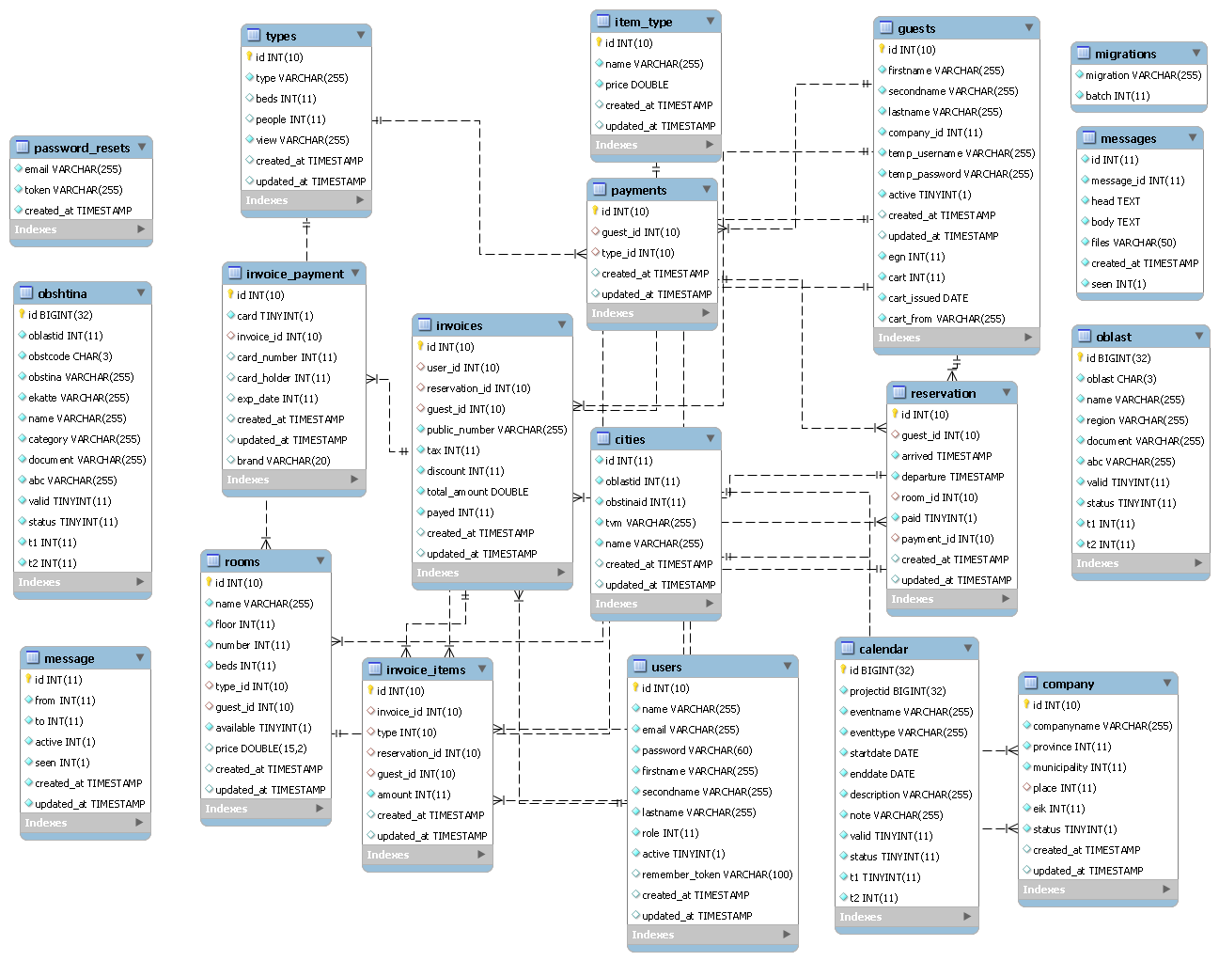

2.2 Functional Requirements Specification
This section outlines the use cases for each of the active readers separately. The reader, the author and the reviewer have only one use case apiece while the editor is main actor in this system.

2.2.1 Guest use case

Use case: Check-in
Diagram:

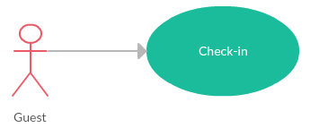

Brief Description
The guest (either walk-in or with reservation one) can make new reservation/check in in the hotel.

Initial Step-By-Step Description
Before this use case can be initiated, the Guest has to have a registration or has to be in front the reception.

- The Guest is confirming his reservation/make new reservation at the receptionist.
- The Guest is choosing the type of room.
- The Guest is giving his credentials.
- The Guest is confirming his registration and receives the keys.

Use case: Check-out
Diagram:
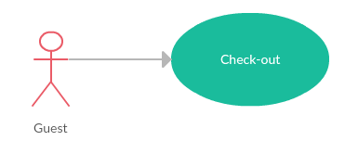

Brief Description
The guest is ready to leave the hotel.

Initial Step-By-Step Description
Before this use case can be initiated, the Guest has to be accommodated in the hotel and be in-front of the reception with the intention to leave the hotel.

- The Guest is confirming his leaving.
- The Guest is paying what he owns.
- The Guest leaves.

2.2.2 Receptionist Use Case
In case The Receptionist must be logged into the system with his credentials.

Use case: View guests
Diagram:
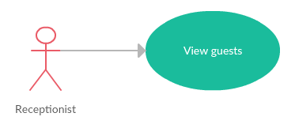
Brief Description
The Receptionist has to be logged in the system with his credentials

Initial Step-By-Step Description
The Receptionist has to be in the “Guests” view in order to proceed

- The Receptionist selects a guest from the list
- On the right side the selected guest is loaded with all the information stored in the database

Use case: Room information
Diagram:
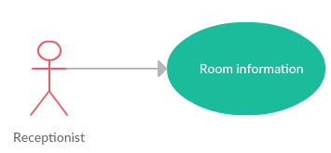
Brief Description
The Receptionist has to be logged in the system with his credentials

Initial Step-By-Step Description
The Receptionist has to be in the “Room” view in order to proceed

- The Receptionist selects room from the list
- The Receptionist is redirected to a new view, containing all the information for the room- type of the room, price, is there a guest currently using the room, a list of guests that are accommodated in the room as well as a list of all past accommodations

Use case: Accommodate a guest
Diagram:
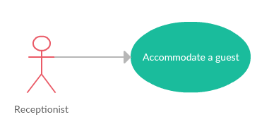
Brief Description
The receptionist is checking-in a guest into the system and with that into the hotel

Initial Step-By-Step Description
Before proceeding, the guest must be legitimized and provide all the information needed for his accommodation

- The Receptionist is checking if the guest is walk-in or with reservation
- The Receptionist is validating his credentials
- The Receptionist is inputting the guest’s information into the system
- The Receptionist is giving the key to the guest’s room

Use case: Edit guest
Diagram:
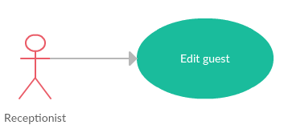

Brief Description
The Receptionist has to be logged in the system with his credentials

Initial Step-By-Step Description
The Receptionist has to be in the “Room” view in order to proceed

- The Receptionist choose from the list of rooms and then presses “Information” button inside the room’s box
- The Receptionist is redirected to a new view, containing all the information for the room- type of the room, price, is there a guest currently using the room, a list of guests that are accommodated in the room as well as a list of all past accommodations
- The Receptionist is then chooses from ”Currently accommodated” tab the guest he wishes to edit
- A helping window on the right side is shown with all the information regarding the guest, which The Receptionist can edit.
- The Receptionist presses the “Edit” and proceeds to apply the changes
- After the changes have been done, The Receptionist presses “Done” and the changes are applied and saved in the database.

Use case: Check-out a guest
Diagram:
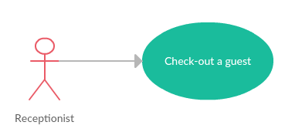
Brief Description
The receptionist is checking-out a guest of the hotel

Initial Step-By-Step Description
No initial information required.

- The Receptionist is checking if the guest is walk-in or with reservation
- The Receptionist is validating his credentials
- The Receptionist is inputting the guest’s information into the system
- The Receptionist is giving the key to the guest’s room

Use case: Report manager
Diagram:
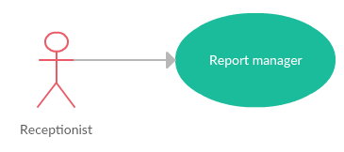
Brief Description
The Receptionist has to be logged in the system with his credentials

Initial Step-By-Step Description
No initial steps are required for this action

- The Receptionist clicks “Reports” button in order to open new view
- The Receptionist is presented with interactive view, which organize the reports, made from him or other users with Receptionist role
- The Receptionist proceed with his initial task

Use case: Add report
Diagram:
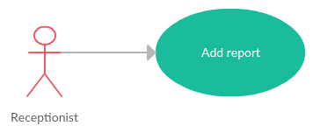

Brief Description
The Receptionist has to be logged in the system with his credentials

Initial Step-By-Step Description
The Receptionist has to be in the “Reports manager”

- The Receptionist clicks “Add new report” button in order to open a modal
- The Receptionist fills the information inside the form
- The Receptionist review and confirm the changes

Use case: Mark report with status
Diagram:
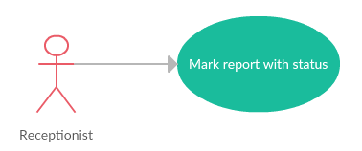
Brief Description
The Receptionist has to be logged in the system with his credentials

Initial Step-By-Step Description
The Receptionist has to be in the “Reports manager”

- The Receptionist clicks “Change status” button in order to open a modal
- The Receptionist review the report, changes its status and confirm his action
- The Receptionist returns to “Reports manager” with the respected changes being applied

Use case: Edit report
Diagram:
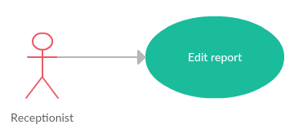
Brief Description
The Receptionist has to be logged in the system with his credentials

Initial Step-By-Step Description
The Receptionist has to be in the “Reports manager”

- The Receptionist clicks “Edit report” button in order to open a modal
- The Receptionist corrects the information inside the form
- The Receptionist is presented with choice to mark this report as “Final version”(default) or “New version” with the soul intend of keeping track of his actions.
- The Receptionist review and confirm the changes

Use case: Calendar management
Diagram:
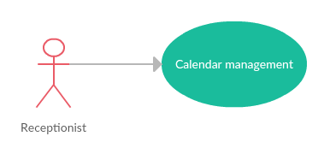
Brief Description
The Receptionist has to be logged in the system with his credentials

Initial Step-By-Step Description
No initial steps are required for this action

- The Receptionist clicks “Calendar” button in order to open new view
- The Receptionist is presented with the calendar for the current month with options to view other months or years
- The Receptionist is proceed with his initial task

Use case: Add event to the calendar
Diagram:
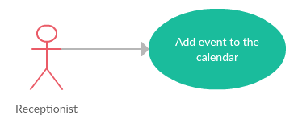
Brief Description
The Receptionist has to be logged in the system with his credentials

Initial Step-By-Step Description
The Receptionist has to be in the “Calendar” view in order to proceed

- The Receptionist fills the form with information
- The Receptionist selects the event’s type
- The Receptionist drag-and-drop the event in the designated date, represented by square in the calendar

Use case: Edit event to the calendar
Diagram:
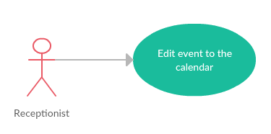
Brief Description
The Receptionist has to be logged in the system with his credentials

Initial Step-By-Step Description
The Receptionist has to be in the “Calendar” view in order to proceed

- The Receptionist clicks on an event in order to open the edit modal
- The Receptionist corrects the information inside the form
- The Receptionist review and confirm his actions

Use case: Remove event to the calendar
Diagram:
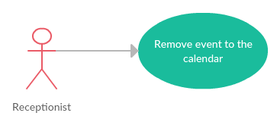
Brief Description
The Receptionist has to be logged in the system with his credentials

Initial Step-By-Step Description
The Receptionist has to be in the “Calendar” view in order to proceed

- The Receptionist selects the event
- The Receptionist review and confirm his action
- The Receptionist is returned to the “Calendar” view with the changes being applied

Use case: View Invoices
Diagram:
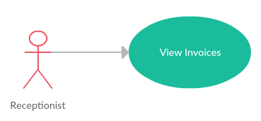
Brief Description
The Receptionist has to be logged in the system with his credentials

Initial Step-By-Step Description
The Receptionist has to be in the “Invoices” view in order to proceed

- The Receptionist clicks on an invoice
- On the right side a window is showed with all the information, regarding the invoice

Use case: Create Invoice
Diagram:
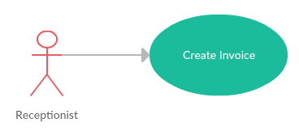
Brief Description
The Receptionist has to be logged in the system with his credentials

Initial Step-By-Step Description
The Receptionist has to be in the “Room” view in order to proceed

- The Receptionist selects the room, that he wishes to wishes to check-out guests of
- The Receptionist then proceed with the checkout procedure, following all the steps
- After the check-out process is done, an invoice is generated automatically.

Use case: Edit Invoice
Diagram:
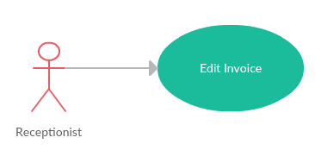
Brief Description
The Receptionist does not possess the legal rights to edit an invoice. Any attempt will be stopped by the system.

Initial Step-By-Step Description
None

Use case: Delete Invoice
Diagram:
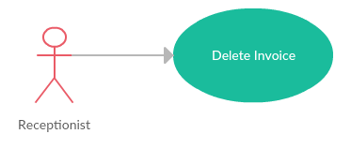
Brief Description
The Receptionist does not possess the legal rights to remove an invoice. Any attempt will be stopped by the system.

Initial Step-By-Step Description
None

2.2.3 Manager Use Case

Use case: Review the reports
Diagram:
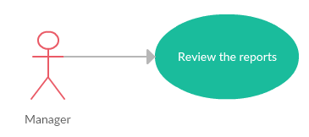
Brief Description
The Manager has to be logged in the system with his credentials

Initial Step-By-Step Description
No initial steps are required for completing this action

- The Manager has to click on the report button in order to open the view
- The Manager has to click on a report
- The Manager is reviewing the report for errors or misplaced information
- The Manager is reviewing the report and, if everything is done right, submit it in the archive

Use case: Room types management
Diagram:
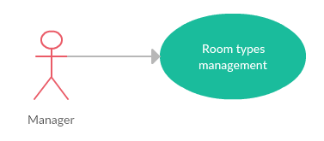
Brief Description
The Manager has to be logged in the system with his credentials

Initial Step-By-Step Description
No initial steps are required for completing this action

- The Manager has to click on the managing button in order to open the view
- The Manager is choosing “Room types” in the secondary menu in order to open “Room types manager”
- The Manager is presented with simplified view, in which he navigate in order to complete the intended task
- The Manager saves the changes

Use case: Add room types
Diagram:
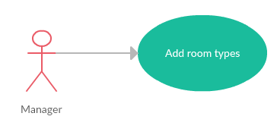

Brief Description
The Manager has to be logged in the system with his credentials

Initial Step-By-Step Description
The Manager has to be in the “Room types manager”

- The Manager clicks “Add new type” button in order to open a modal
- The Manager fills the information inside the form
- The Manager review and confirm the changes

Use case: Remove room types
Diagram:
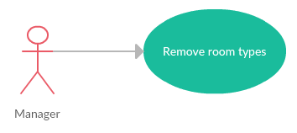
Brief Description
The Manager has to be logged in the system with his credentials

Initial Step-By-Step Description
The Manager has to be in the “Room types manager”

- The Manager clicks “Remove type” button in order to open a modal
- The Manager review the type and confirm his action
- The Manager returns to “Room types manager” with the respected changes being applied

Use case: Edit room types
Diagram:
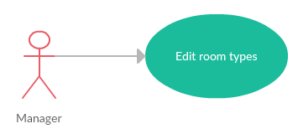
Brief Description
The Manager has to be logged in the system with his credentials

Initial Step-By-Step Description
The Manager has to be in the “Room types manager”

- The Manager clicks “Edit type” button in order to open a modal
- The Manager corrects the information inside the form
- The Manager review and confirm the changes

Use case: Types of Services
Diagram:
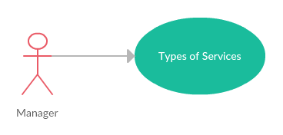
Brief Description
The Manager has to be logged in the system with his credentials

Initial Step-By-Step Description
The Manager has to be in the “Services manager”

- The Manager clicks “Services manager” button in order to open a modal
- The Manager proceed with the task

Use case: Add service
Diagram:
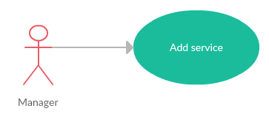
Brief Description
The Manager has to be logged in the system with his credentials

Initial Step-By-Step Description
The Manager has to be in the “Services manager”

- The Manager clicks “Add new service” button in order to open a modal
- The Manager fills the information inside the form
- The Manager review and confirm the changes

Use case: Remove service
Diagram:
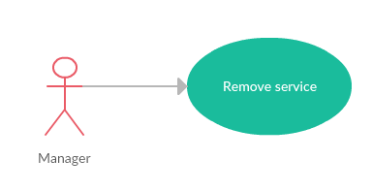
Brief Description
The Manager has to be logged in the system with his credentials

Initial Step-By-Step Description
The Manager has to be in the “Services manager”

- The Manager clicks “Remove service” button in order to open a modal
- The Manager review the type and confirm his action
- The Manager returns to “Services manager” with the respected changes being applied

Use case: Edit service
Diagram:
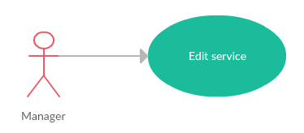
Brief Description
The Manager has to be logged in the system with his credentials

Initial Step-By-Step Description
The Manager has to be in the “Services manager”

- The Manager clicks “Edit service” button in order to open a modal
- The Manager corrects the information inside the form
- The Manager review and confirm the changes

Use case: Report manager
Diagram:
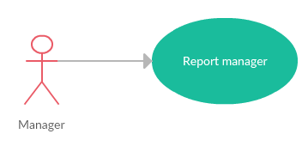
Brief Description
The Manager has to be logged in the system with his credentials

Initial Step-By-Step Description
No initial steps are required for this action

- The Manager clicks “Reports” button in order to open new view
- The Manager is presented with interactive view, which organize the reports, made from other users inside the system as well as reports, created by The Manager
- The Manager proceed with his initial task

Use case: Add report
Diagram:
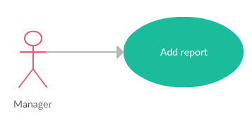
Brief Description
The Manager has to be logged in the system with his credentials

Initial Step-By-Step Description
The Manager has to be in the “Reports manager”

- The Manager clicks “Add new report” button in order to open a modal
- The Manager fills the information inside the form
- The Manager review and confirm the changes

Use case: Mark report with status
Diagram:
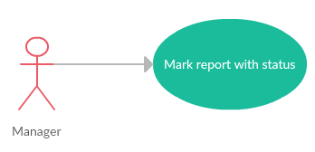
Brief Description
The Manager has to be logged in the system with his credentials

Initial Step-By-Step Description
The Manager has to be in the “Reports manager”

- The Manager clicks “Change status” button in order to open a modal
- The Manager review the report, changes its status and confirm his action
- The Manager returns to “Reports manager” with the respected changes being applied

Use case: Edit report
Diagram:
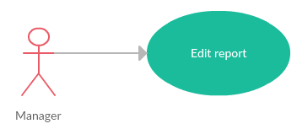
Brief Description
The Manager has to be logged in the system with his credentials

Initial Step-By-Step Description
The Manager has to be in the “Reports manager”

- The Manager clicks “Edit report” button in order to open a modal
- The Manager corrects the information inside the form
- The Manager is presented with choice to mark this report as “Final version”(default) or “New version” with the soul intend of keeping track of his actions.
- The Manager review and confirm the changes

Use case: Calendar management
Diagram:
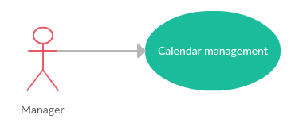
Brief Description
The Manager has to be logged in the system with his credentials

Initial Step-By-Step Description
No initial steps are required for this action

- The Manager clicks “Calendar” button in order to open new view
- The Manager ist is presented with the calendar for the current month with options to view other months or years
- The Manager is proceed with his initial task

Use case: Add event to the calendar
Diagram:
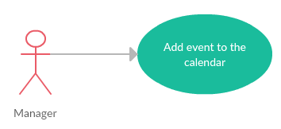
Brief Description
The Manager has to be logged in the system with his credentials

Initial Step-By-Step Description
The Manager has to be in the “Calendar” view in order to proceed

- The Manager fills the form with information
- The Manager selects the event’s type
- The Manager drag-and-drop the event in the designated date, represented by square in the calendar

Use case: Edit event to the calendar
Diagram:
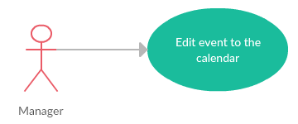
Brief Description
The Manager has to be logged in the system with his credentials

Initial Step-By-Step Description
The Manager has to be in the “Calendar” view in order to proceed

- The Manager clicks on an event in order to open the edit modal
- The Manager corrects the information inside the form
- The Manager review and confirm his actions

Use case: Remove event to the calendar
Diagram:
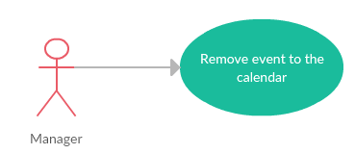
Brief Description
The Manager has to be logged in the system with his credentials

Initial Step-By-Step Description
The Manager has to be in the “Calendar” view in order to proceed

- The Manager selects the event
- The Manager review and confirm his action
- The Manager is returned to the “Calendar” view with the changes being applied

2.3 User Characteristics
The Reader is expected to be Internet literate and be able to use a search engine. The main screen of the Online Journal Website will have the search function and a link to “Author/Reviewer Information.”
The Author and Reviewer are expected to be Internet literate and to be able to use email with attachments.
The Editor is expected to be Windows literate and to be able to use button, pull-down menus, and similar tools.
The detailed look of these pages is discussed in section 3.2 below.

2.4 Non-Functional Requirements
The Online Journal will be on a server with high speed Internet capability. The physical machine to be used will be determined by the Historical Society. The software developed here assumes the use of a tool such as Tomcat for connection between the Web pages and the database. The speed of the Reader’s connection will depend on the hardware used rather than characteristics of this system.
The Article Manager will run on the editor’s PC and will contain an Access database. Access is already installed on this computer and is a Windows operating system.

3.0. Requirements Specification

3.1 External Interface Requirements
The only link to an external system is the link to the Historical Society (HS) Database to verify the membership of a Reviewer. The Editor believes that a society member is much more likely to be an effective reviewer and has imposed a membership requirement for a Reviewer. The HS Database fields of interest to the Web Publishing Systems are member’s name, membership (ID) number, and email address (an optional field for the HS Database).
The Assign Reviewer use case sends the Reviewer ID to the HS Database and a Boolean is returned denoting membership status. The Update Reviewer use case requests a list of member names, membership numbers and (optional) email addresses when adding a new Reviewer. It returns a Boolean for membership status when updating a Reviewer.

3.2 Functional Requirements
The Logical Structure of the Data is contained in Section 3.3.1.

Check-in method

Use Case Name | Check-in
XRef | Section 2.2.2.1- Check-in use case, Section 2.2.2.2 – Accommodate a guest
Trigger | The Guest enters the site
Precondition | The site and the system must be online
Basic Path | The Guest speaks with the receptionist in order to get his credentials into the system
Alternative Paths | None
Postcondition | New guest and reservation have been added to the system
Exception Paths | The attempt may be abandoned at any time.
Other | None

Check-out method

Use Case Name | Check-in
XRef | Section 2.2.2.1- Check-out use case, Section 2.2.2.2 – Check-out a guest
Trigger | The Guest enters the site
Precondition | The site and the system must be online
Basic Path | The Guest speaks with the receptionist in order to get his credentials into the system
Alternative Paths | None
Post condition | A reservation has been terminated
Exception Paths | The attempt may be abandoned at any time.
Other | None

View guests method

Use Case Name | View guests
XRef | Section 2.2.2.2, View guests use case
Trigger | The Receptionist enters “Guests” window
Precondition | The site and the system must be online
Basic Path | The Receptionist navigate through the page, choosing the guest
Alternative Paths | From the “Information” in Rooms view
Postcondition | None
Exception Paths | The attempt may be abandoned at any time.
Other | None

Room accommodation method

Use Case Name | Room accommodation
XRef | Section 2.2.2.3, Room accommodation use case
Trigger | The Receptionist enters “Room” window
Precondition | The site and the system must be online
Basic Path | The Receptionist selects the room and enters the guest credentials in order to insert new record in the database
Alternative Paths | None
Postcondition | New reservation and guest record have been made
Exception Paths | The attempt may be abandoned at any time.
Other | None

Edit guest method

Use Case Name | Edit guest
XRef | Section 2.2.2.4, Edit guest use case
Trigger | The Receptionist enters “Room” window and selects “Information” button inside Room’s box
Precondition | The site and the system must be online
Basic Path | The Receptionist selects the guest that he wishes to edit
Alternative Paths | None
Post condition | A guest’s information has been changed
Exception Paths | The attempt may be abandoned at any time.
Other | None

Check-out method

Use Case Name | Check-out a guest
XRef | Section 2.2.2.5 – Check-out guest use case, Section 2.1.1- Checkout
Trigger | The Receptionist enters “Room” window and selects “Checkout” button inside Room’s box
Precondition | The site and the system must be online
Basic Path | The Receptionist fills the form for checkout and accepts a payment
Alternative Paths | None
Post condition | A reservation has been terminated, a guest is checkout, new invoice has been made, payment has been made
Exception Paths | The attempt may be abandoned at any time.
Other | None

Report CRUD methods

Use Case Name | Report CRUD manager
XRef | Section 2.2.2.6 – Report manager use case, Section 2.2.2.7 –Add report use case, Section 2.2.2.8 – Mark Report with status use case, Section 2.2.2.9 – Edit report use case
Trigger | The Receptionist enters “Reports” window
Precondition | The site and the system must be online
Basic Path | In the “Reports” window, The Receptionist selects between:  - Add report  - Mark report with status  - Edit report
Alternative Paths | None
Post condition | A basic CRUD controller is called to fulfill The Receptionist’s request
Exception Paths | The attempt may be abandoned at any time.
Other | None

Calendar CRUD methods

Use Case Name | Calendar CRUD manager
XRef | Section 2.2.2.10 – Calendar manager use case, Section 2.2.2.11 –Add event use case, Section 2.2. 2.12 – Remove event use case, Section 2.2. 2.13 – Edit event use case
Trigger | The Receptionist enters “Calendar” window
Precondition | The site and the system must be online
Basic Path | In the “Calendar” window, The Receptionist selects between:  - Add event  - Remove event  - Edit event  - Delete event
Alternative Paths | None
Post condition | A basic CRUD controller is called to fulfill The Receptionist’s request
Exception Paths | The attempt may be abandoned at any time.
Other | None

Invoice CRUD methods

Use Case Name | Invoice CRUD manager
XRef | Section 2.2.2.14 – View Invoice use case, Section 2.2.2.15 –Create Invoice, Section 2.2.2.16 – Remove Invoice use case, Section 2.2. 2.17 – Edit Invoice use case
Trigger | The Receptionist enters “Invoice” window
Precondition | The site and the system must be online
Basic Path | In the “Invoice” window, The Receptionist selects between:  - Add event  - Remove event  - Edit event
Alternative Paths | None
Post condition | A basic CRUD controller is called to fulfill The Receptionist’s request
Exception Paths | The attempt may be abandoned at any time.
Other | None

Room type CRUD methods

Use Case Name | Room type CRUD manager
XRef | Section 2.2.3.2 – Room type manager use case, Section 2.2.3.3 –Create Invoice, Section 2.2.3.4 – Remove Invoice use case, Section 2.2. 3.5 – Edit Invoice use case
Trigger | The Manager enters “Rooms manager” window
Precondition | The site and the system must be online
Basic Path | In the “Room type manager” window, The Manager selects between:  - Add room type  - Remove room type  - Edit room type
Alternative Paths | None
Post condition | A basic CRUD controller is called to fulfill The Manager’s request
Exception Paths | The attempt may be abandoned at any time.
Other | None

Service type CRUD methods

Use Case Name | Service type CRUD manager
XRef | Section 2.2.3.6 – Types of service use case, Section 2.2.3.7 –Add service, Section 2.2.3.8 – Edit service use case, Section 2.2. 3.9 – Remove service use case
Trigger | The Manager enters “Services manager” window
Precondition | The site and the system must be online
Basic Path | In the Services manager” window, The Manager selects between:  - Add room type  - Remove room type  - Edit room type
Alternative Paths | None
Post condition | A basic CRUD controller is called to fulfill The Manager’s request
Exception Paths | The attempt may be abandoned at any time.
Other | None

Report CRUD methods

Use Case Name | Report CRUD manager
XRef | Section 2.2.3.10 – Report manager use case, Section 2.2.3.11 –Add report use case, Section 2.2.3.12 – Mark Report with status use case, Section 2.2.3.13 – Edit report use case
Trigger | The Manager enters “Reports manager” window
Precondition | The site and the system must be online
Basic Path | In the “Reports” window, The Manager selects between:  - Add report  - Mark report with status  - Edit report
Alternative Paths | None
Post condition | A basic CRUD controller is called to fulfill The Manager’s request
Exception Paths | The attempt may be abandoned at any time.
Other | None

Calendar CRUD methods

Use Case Name | Calendar CRUD manager
XRef | Section 2.2.3.14 – Calendar manager use case, Section 2.2.3.15 –Add event use case, Section 2.2.3.16 – Remove event use case, Section 2.2.3.17 – Edit event use case
Trigger | The Manager enters “Calendar” window
Precondition | The site and the system must be online
Basic Path | In the “Calendar” window, The Manager selects between:  - Add event  - Remove event  - Edit event  - Delete event
Alternative Paths | None
Post condition | A basic CRUD controller is called to fulfill The Manager’s request
Exception Paths | The attempt may be abandoned at any time.
Other | None

3.3 Detailed Non-Functional Requirements

3.3.1 Logical Structure of the Data
The logical structure of the data to be stored in the internal Article Manager database is given below. 